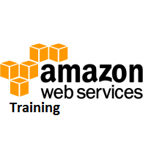

**AWS - Relational Database Service**

**Amazon RDS (Relational Database Service)** is a fully-managed SQL database cloud service that allows to create and operate relational databases. Using RDS you can access your files and database anywhere in a cost-effective and highly scalable way.

**Features of Amazon RDS**

Amazon RDS has the following features −

* **Scalable** − Amazon RDS allows to scale the relational database by using AWS Management Console or RDS-specific API. We can increase or decrease your RDS requirements within minutes.
* **Host replacement** − Sometimes these situations occur when the hardware of Amazon RDS fails. There is no need to worry, it will be automatically replaced by Amazon.
* **Inexpensive** − Using Amazon RDS, we pay only for the resources we consume. There is no up-front and long-term commitment.
* **Secure** − Amazon RDS provides complete control over the network to access their database and their associated services.
* **Automatic backups** − Amazon RDS backs up everything in the database including transaction logs up to last five minutes and also manages automatic backup timings.
* **Software patching** − Automatically gets all the latest patches for the database software. We can also specify when the software should be patched using DB Engine Version Management.

**Cost of Amazon RDS**

When using Amazon RDS, pay only for only the usage without any minimum and setup charges. Billing is based on the following criteria −

* **Instance class** − Pricing is based on the class of the DB instance consumed.
* **Running time** − Price is calculated by the instance-hour, which is equivalent to a single instance running per hour.
* **Storage** − Bill is calculated as per the storage capacity plan chosen in terms of per GB.
* **I/O requests per month** − Billing structure also includes total number of storage I/O requests made in a billing cycle.
* **Backup storage** − There is no additional charges for backup storage up to 100% of database. This service is free only for active DB instances.

**How to Set Up Amazon RDS?**

**Step 1** − Login to AWS management console. Use the following link to open Amazon RDS console − <https://console.aws.amazon.com/rds/>

**Step 2** − Select the region where the DB instance is to be created, at the top right corner of the Amazon RDS console.

**Step 3** − Select Instances in the navigation pane, then click Launch DB Instance button.

**Step 4** − The Launch DB Instance Wizard opens. Select the type of instance as required to launch and click the Select button.

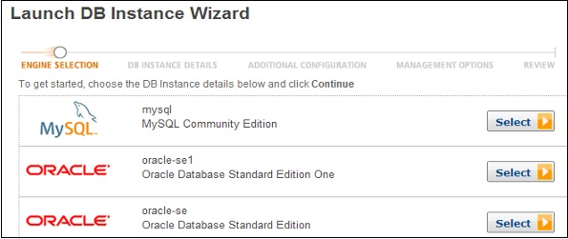

**Step 5** − On the Specify DB Details page, provide the required details and click the Continue button.

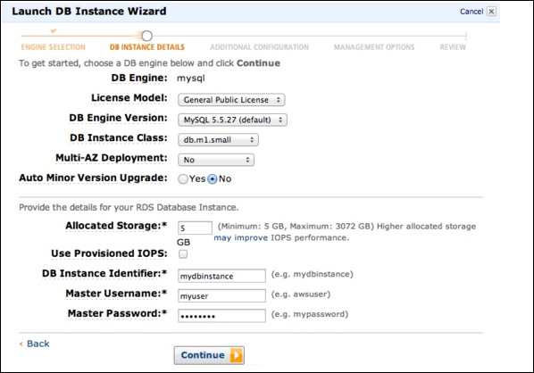

**Step 6** − On the Additional configuration page, provide the additional information required to launch the MySQL DB instance and click the Continue button.

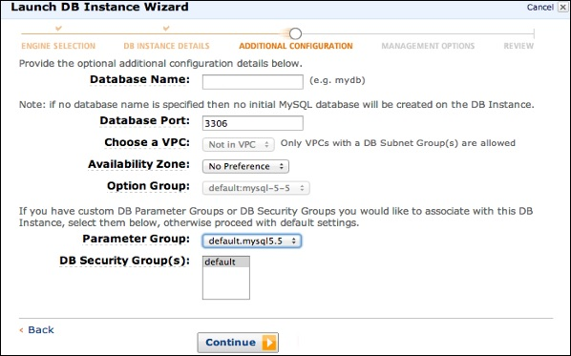

**Step 7** − On Management options page, make the choices and click the Continue button.

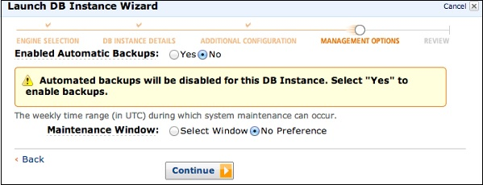

**Step 8** − On the Review page, verify the details and click the Launch DB Instance button.

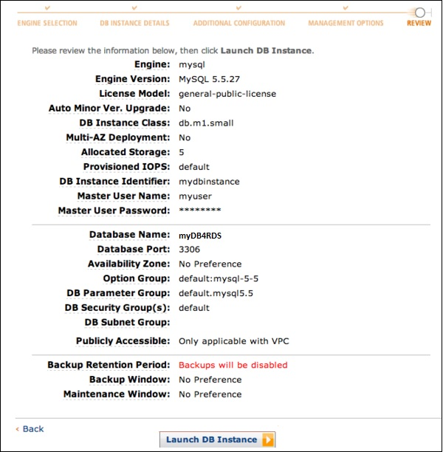

Now DB instance shows in the list of DB instances.

**How to Connect Database to MySQL DB Instance?**

Following are the steps to connect a database on MySQL DB instance −

**Step 1** − Type the following command in the command prompt on a client computer to connect a database on MySQL DB instance (using the MySQL monitor).

**Step 2** − Replace <myDBI> with DNS name of your DB instance, <myusername> with your master user-name & <mypassword> with your master password.

PROMPT> mysql -h <myDBI> -P 3306 -u <myusername> -p

After running the above command, the output looks like −

Welcome to the MySQL monitor. Commands end with ; or \g.

Your MySQL connection id is 350

Server version: 5.2.33-log MySQL Community Server (GPL)

Type 'help;' or '\h' for help. Type '\c' to clear the buffer.

mysql>

**How to Delete a DB Instance?**

After completing the task, we should delete the DB instance so will not be charged for it. Follow these steps to delete a DB instance −

**Step 1** − Sign in to the AWS Management Console and use the following link to open the Amazon RDS console.

<https://console.aws.amazon.com/rds/>

**Step 2** − In the DB Instances list, select the DB instances to be deleted.

**Step 3** − Click the Instance Actions button and then select the Delete option from the dropdown menu.

**Step 4** − Select No in the Create Final Snapshot.

**Step 5** − Click the Yes, Delete to delete the DB instance.